Rough Estimates of Temperature of a Thin Aluminum Solar Filter.
Preliminary 7/21/99 CMB

Simplest case: Free Standing Filter

Assume no thermal conduction since material is very thin.
Assume no convection.
Assume an infinite sheet seeing the sun on one side and the instrument on the other,
Solar Input is 1360 W/m²
View factor for deep space (~0ºK) is 1.0 on sunlit side
View factor for instrument is 1.0 on reverse side.
Instrument temperature is Ts. Its emissivity ε =1.0
Foil temperature is T1 (to be calculated)
Foil properties are α₂, ε₂ on the sunward side and are α₁, ε₁ on the instrument side.
σ = 5.67 * 10⁻⁸ W/m²K⁴ – Stefan-Boltzmann Constant.

We then write the equation for thermal balance by radiation. Note that this is independent of the thermal conductivity and heat capacity of the materials:

$$\text{1360}×α_{2}−σ×ε_{2}T_{1}^{4}={\text{σε}}_{1}(T_{1}^{4}−T_{s}^{4})$$

Or
$$T_{1}^{4}=\frac{\text{1360}∗α_{2}+{\text{σε}}_{1}T_{s}^{4}}{σ(ε_{1}+ε_{2})}$$
and the heat radiated into the instrument by the filter (per square meter) is given by

$$Q_{1}={\text{σε}}_{1}(T_{1}^{4}−T_{s}^{4})$$

Some reported values of thermal finish properties are:

Material | α | ε
Aluminum vapor deposited | 0.08 | 0.02
Buffed Aluminum | 0.16 | 0.03
Polished Aluminum BOL | 0.15 | 0.05
Polished Aluminum EOL | 0.15 | 0.05
Heavily oxidized Al | 0.13 | 0.30
Black Nickel | 0.91 | 0.66
Electroless Nickel | 0.39 | 0.07
Electroplated Nickel-polished | - | 0.05
Electroplated Nickel-unpolished | - | 0.11
Nickel – Oxidized | - | 0.37
SS sandblasted | 0.58 | 0.38
SS Polished | 0.42 | 0.11
SS Machine rolled | 0.39 | 0.11
SS 18-8 Buffed | - | 0.16
SS 18-8 Oxidized @ 800C | - | 0.85
SS 18-8 sandblasted | 0.78 | 0.44

These are illustrative of the range of values one encounters. The values depend strongly on surface finish and the effects of aging. If we take the aluminum filter to be ~1500A of vapor deposited aluminum on a nickel mesh backing, α₂ for the sunward side should be in the range near 0.08. I’ve heard of values as low as 0.05 and a worst case would be 0.15. ε₂ should be in the range 0.027 – 0.036. For the rear surface, we can take the properties to be 90% Al and 10% Ni mesh. A high ε here helps keep the foil cool, so one could think about blackening the mesh somehow (using blackened nickel mesh gives a ~30 deg drop in T1). For the moment, I’ll use ε₁ = 0.027 – 0.036 for Al (90%) and 0.05 – 0.11 for Ni (10%) or 0.029 – 0.043 for the combination. For T_{s} I’ll use 293K.

Table 1. Results for Free-Standing Foil
α₂ | ε₂ | ε₁ | T_{s} (K) | T₁ (K) | Q (W/m²)
.05 | .02 | .03 | 293 | 410 | 36
.05 | .036 | .043 | 293 | 372 | 29
.08 | .03 | .04 | 293 | 421 | 55
.08 | .036 | .043 | 293 | 410 | 51
.1 | .03 | .04 | 293 | 442 | 70
.1 | .036 | .043 | 293 | 430 | 66
15 | .027 | .029 | 293 | 510 | 100

To first order, changing Ts by 10 deg or so raises or lowers T1 by a similar amount.

Filter inside a tube.
Making things a little more realistic, if the filter is buried in the telescope tube, the view factor for deep space is reduced. A 20 cm dia filter in a 25 cm dia tube 25 cm deep has a view factor of 0.08 for deep space and a view factor of 0.92 for the walls of the tube. So the equations become:
$$\text{1360}×α_{2}−0\text{.}\text{08}∗σ×ε_{2}T_{1}^{4}−0\text{.}\text{92}∗σ∗ε_{2}∗(T_{1}^{4}−T_{s}^{4})={\text{σε}}_{1}(T_{1}^{4}−T_{s}^{4})$$
Or
$$T_{1}^{4}=\frac{\text{1360}∗α_{2}+σ(0\text{.}\text{92}∗ε_{2}+ε_{1})T_{s}^{4}}{σ(ε_{1}+ε_{2})}$$
The heat radiated into the rear section is still given by
$$Q_{1}={\text{σε}}_{1}(T_{1}^{4}−T_{s}^{4})$$
but there is an additional term for the heat radiated by the filter into the front telescope tube:
$Q_{2}=0\text{.}\text{92}∗{\text{σε}}_{2}(T_{1}^{4}−T_{s}^{4})$ Here I assume for simplicity that the tube is the same temperature as the rest of the spectrometer.
Recall that the Q values are “per square meter” so for a filter 20 cm in diameter, the area is only 0.0314m² or 1.57 W for a Q of 50 W/m².

Table 2. Results for Filter in a 25 cm Long Tube.
α₂ | ε₂ | ε₁ | T_{s} (K) | T₁(K) | Q₁ W/m² | Q₂ W/m²
.05 | .02 | .03 | 293 | 420 | 36 | 30
.05 | .036 | .043 | 293 | 386 | 36 | 46
.08 | .03 | .04 | 293 | 431 | 62 | 46
.08 | .036 | .043 | 293 | 427 | 59 | 49
.1 | .03 | .04 | 293 | 451 | 77 | 58
.1 | .036 | .043 | 293 | 440 | 73 | 61
.15 | .027 | .029 | 293 | 516 | 105 | 98
0 | .027 | .029 | 293 | 290 | -0.47 | -0.40

The conclusion is that the filter runs ~10 deg hotter inside a tube. Also, some of the heat that would have been radiated to deep space is radiated to the forward section of the telescope tube. Filter temperatures of 450K (177C) can be anticipated. The filter will cycle between Ts (~20C) and T1 (~177C) whenever the door is opened or closed. The last line in Table 2 refers to a case where there is no solar input (S/C pointed away from sun, door open). In this case, the filter drifts to a temperature slightly less than Ts, and there is a loss of 0.87 W/m² to deep space. Were in not for the large view factor for the inside surface of the telescope tube, the temperature would fall to ~250K with a loss of 5.8W/m² to deep space. If the telescope door is closed (normal) the filter drifts to Ts.

Thermal Conductivity of the Filter

The filter does have some conductivity, which will help reduce the temperature. Here, I consider the effective properties of a 1 cm square of the filter and will use that in a simplified model. The filter is nominally 1500 A thick Al, so a square centimeter of the foil has a perpendicular cross sectional area of 1.5x10⁻⁵ cm². The thermal conductivity of pure aluminum is 2.15W/cmK, so 3.23 x 10⁻⁵ W will flow laterally across a 1 cm square film with a 1 deg. temperature difference on two edges.

A 70 l/in Ni mesh supports the foil. The wire thickness is 0.005mm, the width is 0.018mm and the space is 0.344mm for a period of 0.362mm, or 27.6 wires/cm. This gives a sectional area of 2.48 x 10⁻⁵cm² of nickel for the 1 cm square sample. The thermal conductivity of nickel is 0.54 W/cmK so it will carry 1.34 x 10⁻⁵ W for a 1 deg difference as above. For simplicity, I have assumed that the wires line up with the flow direction and have pure Nickel properties.

The total thermal conductivity of 1 cm² is estimated to be 4.5 x 10⁻⁵ W/K for the composite foil & mesh.

Heat Capacity of the Filter
The heat capacity of pure aluminum is 0.96 J/gK, and for Ni is 0.43 J/gK The density of Ni is 8.86 and that of Al is 2.71. A square centimeter of the aluminum weighs 2.71*1.5x10⁻⁵g = 4.06 x 10⁻⁵g for a heat capacity of 1.9x10⁻⁵ J/K. Likewise, for the mesh, I get 4.4x10⁻⁴g for a heat capacity of 1.89x10⁻⁴ J/K. The implication is that the heat flows in the paragraph will significantly cool the filter since its net heat capacity is 2.08 x 10⁻⁴ J/K.

Finite Element Model of Heat Flow
A simplified model of the filter will be studied by the finite element method. The filter is assumed to be 20 cm in diameter, for an area of 314.16 cm². It is partitioned into 10 concentric rings (nodes) of equal area (31.416 cm²) with an eleventh node being the mounting ring (at Ts). Each ring then has the same mass, same heat capacity, same solar input, same view factor, etc., etc., but the rings diminish in width geometrically from center to edge. This makes the math the easiest.

NODE | Area  Encircled  (cm²) | outside  radius  (cm) | Inside  Radius  (cm) | Mean  Radius  (cm) | Rij  (cm) | Circum-  ference | Mass Al  ( g) | Mass Ni  (g) | Heat Cap (J/K)
1 | 31.4159 | 3.1623 | 0.0000 | 0.0000 |  | 19.8692 | 0.0013 | 0.0138 | 0.0072
2 | 62.8319 | 4.4721 | 3.1623 | 3.8730 | 3.8730 | 28.0993 | 0.0013 | 0.0138 | 0.0072
3 | 94.2478 | 5.4772 | 4.4721 | 5.0000 | 1.1270 | 34.4144 | 0.0013 | 0.0138 | 0.0072
4 | 125.6637 | 6.3246 | 5.4772 | 5.9161 | 0.9161 | 39.7384 | 0.0013 | 0.0138 | 0.0072
5 | 157.0796 | 7.0711 | 6.3246 | 6.7082 | 0.7921 | 44.4288 | 0.0013 | 0.0138 | 0.0072
6 | 188.4956 | 7.7460 | 7.0711 | 7.4162 | 0.7080 | 48.6693 | 0.0013 | 0.0138 | 0.0072
7 | 219.9115 | 8.3666 | 7.7460 | 8.0623 | 0.6461 | 52.5689 | 0.0013 | 0.0138 | 0.0072
8 | 251.3274 | 8.9443 | 8.3666 | 8.6603 | 0.5980 | 56.1985 | 0.0013 | 0.0138 | 0.0072
9 | 282.7433 | 9.4868 | 8.9443 | 9.2195 | 0.5593 | 59.6075 | 0.0013 | 0.0138 | 0.0072
10 | 314.1593 | 10.0000 | 9.4868 | 9.7468 | 0.5272 | 62.8319 | 0.0013 | 0.0138 | 0.0072
11 |  | 10.0000 |  | 10.0000 | 0.2532 | 62.8319 | 0.0013 | 0.0138 | 0.0072

This table summarizes the geometric data on the nodes. The Rij column gives the center-to center distance between nodes. The circumference column times 4.5x10⁻⁵ *ΔT/Rij gives the conductive heat flow between two adjoining nodes.
The solar load is 31.4159*α*0.1360W =4.27*αW
The heat radiated to space is 0.08*31.4159*ε₂*σ*(T_{i}⁴-4⁴)
The heat radiated to the front telescope tube is 0.92*31.4159*ε₂*σ*(T_{i}⁴-T_{s}⁴)
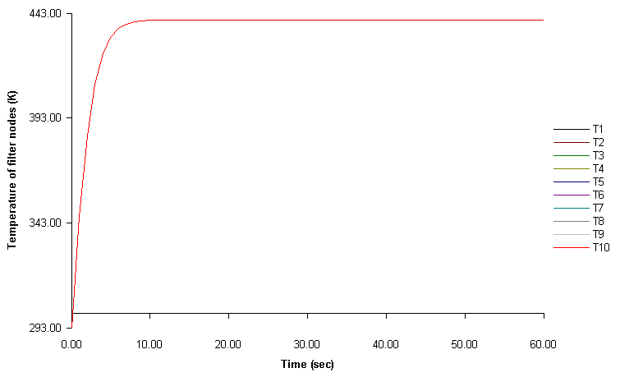
The heat radiated to the rear telescope tube is 1.0*31.4159*ε₁*σ*(T_{i}⁴-T_{s}⁴)
σ is the Stefan-Boltzmann constant, 5.67 * 10⁻¹² W/cm²K⁴
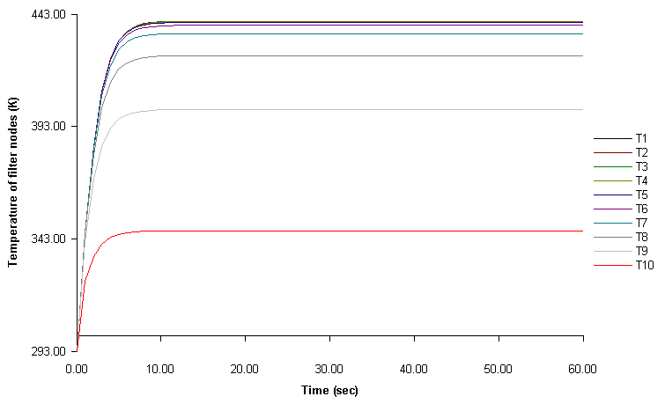
Shown below are plots of the temperature (K) of the ten filter nodes without conduction and with conduction. Cases shown are for ε₁ = 0.04, ε₂=0.03, and α₂ = 0.1, and other cases are quite similar. The central zone comes to about the same temperature, 440K, in both cases but the nodes get successively cooler as they get closer to the frame when conduction is considered. Since the filter operates in vacuum, no convective term is present.

Summary of heat flows:
Solar heat input to filter 4.27W
Heat radiated to deep space 0.14W
Heat radiated to front telescope tube 1.84W
Heat radiated to rear telescope tube 1.70W
Heat conducted to filter frame 0.61W

