SOLAR – B EIS Radiator Thermal Study MSSL

Preliminary study of radiator positioned mid-way along EIS

- CCD temperature aim: -80°C

- CCD dissipation: 2 x 0.5W

- No other dissipation considered

EIS CONFIGURATION STUDIED

THERMAL ENVIRONMENT and ASSUMPTIONS

- Orbit: 600 x 600 km, i = 97.8°, 6pm ascending node.

- Winter Solstice (provisional hot case)

- Spacecraft Sun-pointing

- Total isolation of radiator from structure assumed

- No heat load from camera electronics

EIS Radiator Preliminary Thermal Model (1)

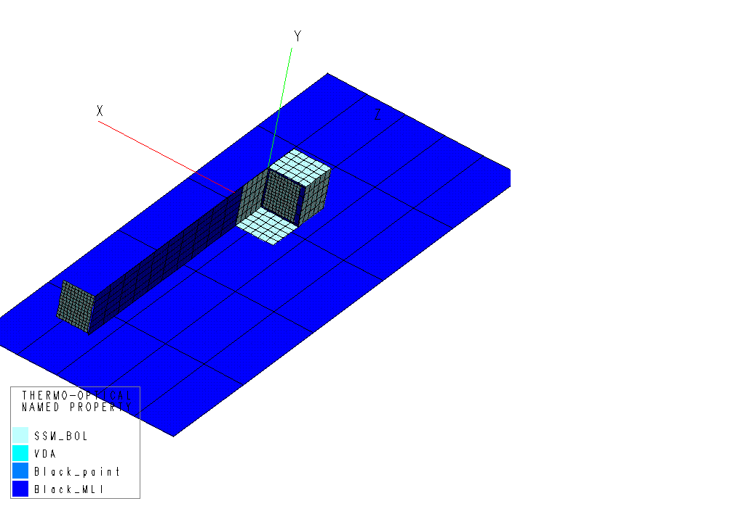

EIS Radiator Preliminary Thermal Model (2)

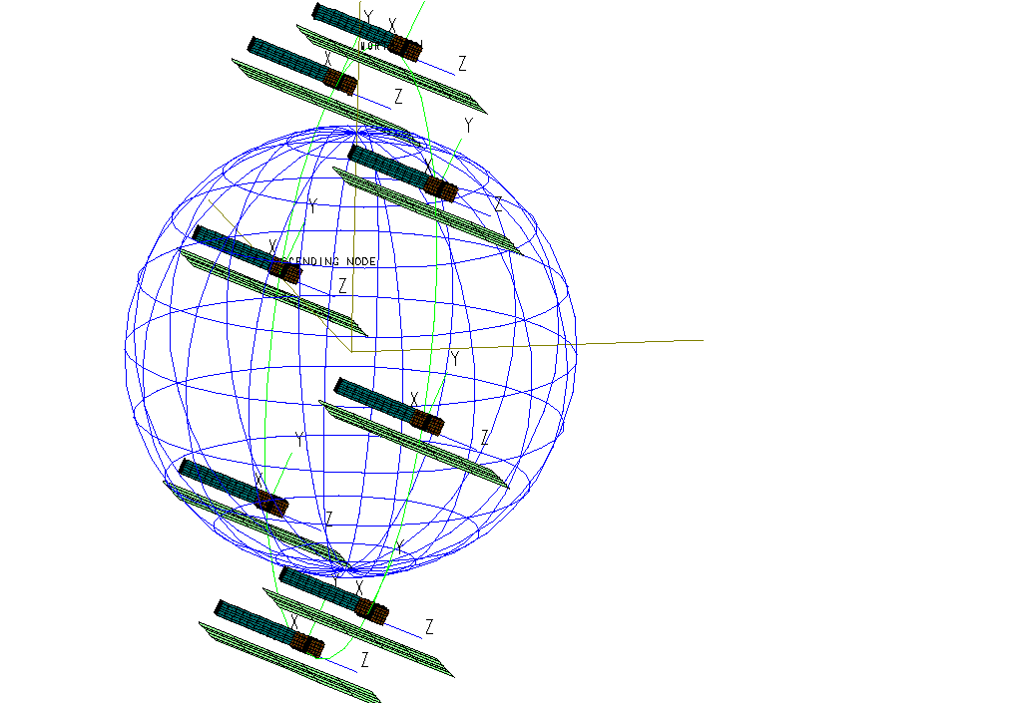

CONFIGURATIONS ANALYSED

- 190 x 230 mm radiator

- With Earth shield around radiator

- Radiator angled away from spacecraft

- Radiator extensions on +Y and –Z faces

- Additional extensions –Z side of main radiator

- 190 x 230 mm radiator at –Z end of EIS

THERMAL PREDICTIONS

Radiator temperature predictions (max. and min. around orbit):-

Note: Model has low heat capacity - true orbital variations will reduce.

Config. 1 (baseline) -80°C to -12°C (average -45°C)

Config. 2 (Earth shields) -70°C to -10°C (average -40°C)

Config. 3 (angled radiator) -83°C to -7°C (average -45°C)

Config. 4 (radiator extensions) -70°C to -30°C (average -50°C)

Config. 5 (additional extensions) -70°C to -30°C (average -50°C)

Config. 6 (rear radiator) -65°C to -45°C (average -55°C)

Comparison: XRT -75°C to -55°C (average -65°C)

DISCUSSION

- Current radiator position seems inadequate for -80°C on CCD

- Earth shields and alternative thermal finishes are not effective

- due to blockage of view factor to Space by rear of EIS and spacecraft

Radiator on rear face of EIS is more effective due to uninterrupted view to Space – does receive more Earthshine & Albedo

- Optimisation (pointing angle, Earth shields) should reduce temperatures to -65°C average, in line with XRT analysis.

WAY FORWARD

- Optimise current radiator with extensions / active louvres
- Unlikely to achieve -80°C

- Heat pipe link to rear radiator
- Not enough power to activate heat pipe?

- Peltier (Thermo-electric) cooler and heat pipe to rear radiator
- Power, mass & complexity implications

- Redesign instrument with rear-mounted radiator

• Review -80°C CCD temperature requirement

