Detector Calibration Analysis Plan
Document Number: ReSIK/MSSL/PL/DCAP-00
Draft: 0.28
Date: 4 July 2001
Author: Matthew Whyndham
Summary 2
Introduction 2
Detector description 2
Analysis Objectives 3
Detailed Objectives 3
Calibration Procedures 4
Introduction 4
Deficiencies of laboratory characterisation 4
Requirements of calibration data 4
Measurement procedure 4
Micro-Slot mask 5
Equipment 5
Data sets 6
Data acquisition 6
File format 6
Data transfer 6
Data analysis 6
Analysis software 6
Peak fitting and subsequent analysis 6
Pulse height analysis and interpretation 7
Determination of detector MTF 7
Schedule 7
Documentation 7
References 8

Summary
This is an outline plan for the analysis of the data produced during calibration of the ReSIK detector. It presents the activities that will be necessary so that the calibration data may be used as part of the ReSIK instrument calibration.
The calibration analysis objectives are given in some detail.
A brief description is given of the calibration activity itself, although this is described more fully in a further report.
The format of the analysis results is described as anticipated, although this will be the subject of another report.

Introduction
ReSIK is a scientific instrument for solar physics research has been prepared for the Russian KORONAS-F satellite. The instrument is currently under development by a consortium of institutes namely:
Space Research Centre (SRC), Solar Physics Division of the Polish Academy of Sciences, Poland
Mullard Space Science Laboratory (MSSL), Department of Space and Climate Physics, University College London (UCL), UK
Rutherford Appleton Laboratory (RAL), UK)
Naval Research Laboratory (NRL), Washington DC, USA
The instrument uses two position sensitive proportional counters to detect soft X-rays reflected from crystals of various types. The ReSIK detectors are identical to those used in the Solar-A (Yohkoh) BCS instrument. The Solar-A spare units have been used for the ReSIK instrument. The detectors are designed and manufactured by MSSL.
Equipment at RAL was used to calibrate the Yohkoh detectors and the Yokhoh spectrometers. The same equipment was used to calibrate the ReSIK detectors and the assembled spectrometers. This was done in July and August 2000.
This document is a plan for the analysis of the data gathered during the calibration of the detectors. It describes how the data will be analysed and how the results of the analysis will be recorded.
In order to be scientifically useful, the detector analysis results will have to be combined with calibration data for the crystals and the spectrometers. The analysis of these data and the combination into a full (integrated) instrument calibration is not described in this report.

Detector description
The BCS/ReSIK detector is a proportional counter with a one dimensional position sensitive readout. It is optimised for detection of X-rays in the 2-7 keV energy range, and for use in a space environment. It features low mass, small volume, low power consumption, and long life. Preamplifiers and test circuitry are mounted in a package on the rear of the detector. No gas supply system is required, as the detector is sealed permanently. Each detector requires a single source of stabilised high voltage, in the range 1300-1600 V, depending on the application. It emits four analog pulses, which require further processing to yield the event positions. The detector has two anode channels so it can be used to observe two sources simultaneously.
A full description of the detectors is given elsewhere.

Analysis Objectives
- (1) Produce a detector calibration report describing the activities in the calibration campaign.
- (2) Analyse all the relevant data from the ReSIK calibration campaign in summer 2000.
- (3) Produce data files of the analysis of which can be used in the integrated instrument calibration analysis.
- (4) Produce an detector analysis report describing the detector analysis procedures (as performed).
- (5) Document the software used and developed for this purpose.
- (6) Publish or otherwise distribute the reports and calibration data so that they may be used by other members of the ReSIK team.
The work should be concluded in a reasonable time so that full use may be made of all the instrument data in the first few months of flight. Assuming that the launch goes ahead in June 2001, this would imply having these products ready by about September 2001.
Is expected that all the analysis work will be carried out at MSSL, with the possible exception of the calibration report, which may be prepared with the co-operation of other members of the team.

Detailed Objectives
(1) Detector calibration report
3.4.1 Write Experiment Basic Description
List equipment used, describing any unusual apparatus. The configuration of the ReSIK electronics box should be carefully logged. Details of source conditions and beam line settings.
Date and time of calibration runs. For each calibration run a set of parameters including the detector voltage, anode type, source settings (voltage and current in x-ray set), monochromator crystal settings, slit settings and position, mounting position of the detector (use of spacer or alternate mounting holes in the detector fixture) as well as the complete list of files taken in that run.
Each file should have the time and approximate duration stated, as well as the directory in which it is stored.
(2) Data analysis
Prepare data set index, which should be machine-readable. [WBS code 3.3.1 – refer to schedule]
Confirm the readability of all files in the index. [3.3.2]
Develop a fitting technique that can accommodate the slit images found in the test files. [3.3.3]
Develop a routine which will execute the fitting algorithm on each of the files in the data set index [3.3.4]. Some fits will have to be adjusted manually. [3.3.6]
The stored results of the fit must themselves be assembled and the results fitted to yielding linearity and other measures. [3.3.7] [3.3.8]
Summary plot of this data. [3.3.10]
(3) The linearity and other data to be prepared for future calibration analysis. [3.3.9]
(4) Detector analysis report comprised of:
3.4.3 w. Fitting Procedure Description
3.4.4 w. Output Data Description
3.4.5 w. section in Cal. Report
(5) Software documentation
3.4.2 w. Fitting Software Description
(6) Publication of results
3.4.6 Publish Reports and Data

Calibration Procedures
Full details have the measurement procedures will be given in the detector calibration report. Complete details of the data analysis procedures will be given in the the detector analysis report. A brief outline is given here in order to aid interpretation of this analysis plan.

Introduction

Deficiencies of laboratory characterisation
Although the detectors have been extensively characterised in the laboratory, these tests cannot be used for a flight calibration. There are two reasons for this. Firstly, the short length of the vacuum chamber used in the lab means that the off-axis X-rays enter the detector at a slight angle. Because X-rays are absorbed over a few millimetres in the detector gas, this gives a distortion or blurring of the position of an image spot towards the ends of the detector. Secondly, the X-ray source available was capable of emission in a broad band of energies only. A full calibration requires a more faithful representation of the wavelengths reflected by the spectrometer crystals.

Requirements of calibration data
The output data should represent the following features:
- Relationship between wavelength and bin number
- Description of the appropriate HV setting, with pulse height distributions if available
- Description of the relative sensitivity along the detector. This will need to be known to rather high-precision (a few per cent say) and is necessary for determination of line ratios DEM and abundance studies.
- The instrument profile, i.e. the MTF, will be of interest, especially the wing profiles (obtained from a long exposures of or summations of data sets ). The wings may contribute to the continuum and are therefore important for the absolute continuum level estimates.
This is required for each detector and order available (in some cases second order reflections are forbidden ), giving 10 sets in all.

Measurement procedure
The calibration tests were carried out in a similar way to the Yohkoh detector calibration tests. An X-ray apparatus at RAL, having a reasonably long beam length and the ability to provide monochromatic X-rays to the detector by means of a double reflecting crystal, was used in conjunction with a specially fabricated slot mask.
The X-ray set is configured with an appropriate anode (target), and the source conditions adjusted to provide a reasonable flux. The energy emitted by the source consist of some characteristic X-rays and a Bremstrahlung continuum. A double quartz crystal mounted on a turntable enables the selection of a particular energy. Slits along the length of the beam line further limit the angular dispersion of the X-rays reaching the detector plane.
In many respects, the measurement procedure is similar to the instrument calibration procedure, and uses the same equipment. Refer to the Solar-A (Yohkoh) instrument calibration report for more details. An instrument calibration report for ReSIK will also be written.

Micro-Slot mask
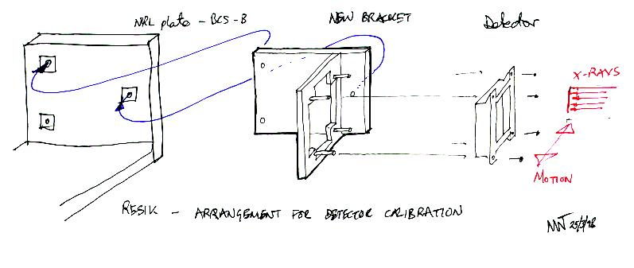
Figure 1. Illustration of RAL beam scanning the slot mask.
The micro slot mask is unique to the detector calibration activity. It is attached to the detector using a special frame. The slots run across the detector. The RAL beam is vertical. Figure 1 is not what what used. In fact, the slots were oriented vertically too, so that each detector position illuminated a small number of slots. See Figure 2.
Mounting of the detector to the fittings of the RAL vacuum chamber also requires specific apparatus - the Detector Mounting Fixture.
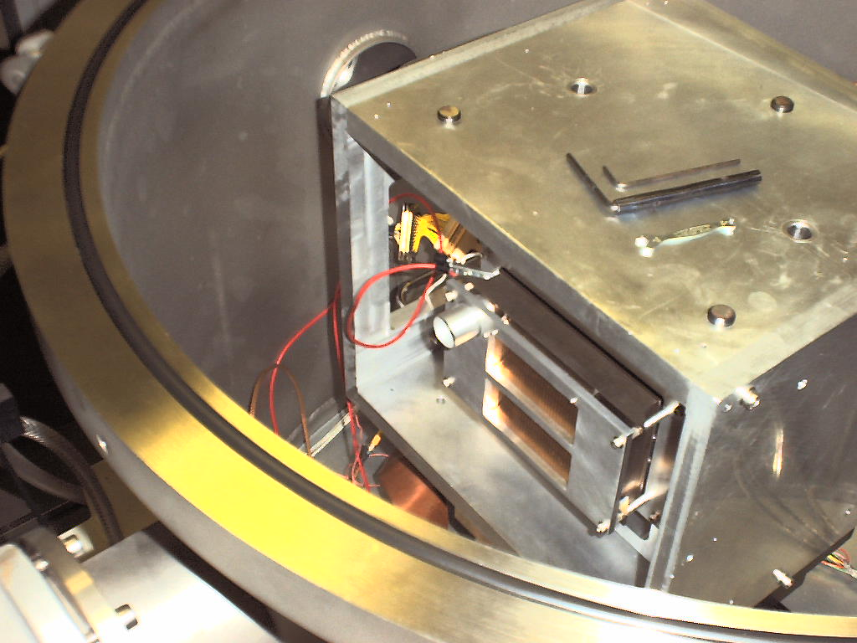
Figure 2. Photo of the detector mounted in the RAL tank, beam and slots vertical.

Equipment
Some other special equipment was used for the detector tests, in addition to that used for the instrument calibration. Full details will be given in the detector calibration report, but the equipment included:
High-voltage supplier and meter
High-voltage connecting cables
…

Data sets
The data sets consist of a number of files, each of which represents an integration of counts with the detector in a particular position with respect to the X-ray beam. Each data file contains some information about the condition of the the read-out electronics, values of the encoded position bins, and also the contents of the pulse height analyzer in the electronics unit.
Each calibration data set comprises a number of these files, each of which was taken at a different position of the detector, or setting of the high-voltage or electronics parameters.

Data acquisition
The data was obtained in an interactive manner, with human control of the apparatus. No scripts or automation were used. The basic activities were:
Determine the high-voltage most suitable for the calibration.
Move the detector so that the beam strikes the end of the slot mask.
Acquire a series of files at a number of positions along the mask.
For each acquisition a descriptive string was entered at the instrument console. This is recorded within each data file, and also in the lab notebook. The file names are generated automatically and are related to that time at which the file is written to disc. Since this is often a few minutes after as a file was started (and the PC clock can drift - interrupts being turned off for data acquisition!), the manual records must be used to accurately correlate each file with the beam position.
Other information about experimental conditions and so one are contained in the manual records, and the detector calibration report will summarise the relevant information from these records.

File format
The files are text-oriented (ASCII characters only) and are therefore human readable. They are machine-readable in the sense that the format is fixed.
A simple IDL procedure can be used to read in these files and store the instrument parameters and counter values in variables and arrays.

Data transfer
The data files were transferred from the instrument controller PC to other computers by ftp.

Data analysis

Analysis software
It is expected that most of the analysis software will be written in IDL. Some thought needs to be given as to whether to use any particular software libraries (such as solarsoft). The main requirement ought to be that the analysis should be repeatable within any of the partner institutes. All use of library routines needs to be documented.
Handling of the experiment database could be done in applications other than IDL, such as Access or Excel.
Some data management routines will be required to assemble data files corresponding to a calibration set.

Peak fitting and subsequent analysis
The experimental procedure was designed so that the test beam illuminated only a few of the slots at any time. It should therefore be a comparatively simple matter to fit a distribution to the profiles thereby determining the apparent position recorded by the detector. By contrast, the Solar-A detector calibration produced data files containing images of many slots (about 20) illuminated at once, thereby adding complexity to the fitting procedures. In practice it was found that about five slots were illuminated by the beam. It may be necessary to design a fitting procedure that uses all five of these peaks.
It is expected that some variation of the IDL procedure gaussfit can be used, as has been done in the past. In contrast to the Solar-A calibration, there is no need to extract the data from a formatted telemetry stream. The files are simply read in directly. A number of routines have already been written that do this.
Some of the peak fitting may fail, due to statistical irregularities in the data, and there may be instances where manual intervention is needed to set up the fit. All the fits should be plotted graphically so that their validity can be checked. It may be thought necessary to print out some reports of all these fields-although if the fits are successful then these plots aren't particularly useful in themselves.
With the peak fitting having been done, the data management software should then assemble the results. These aggregations of the primary analysis are then themselves analysed (linear or polynomial curve fitting) to determine linearity parameters and so on.
A summary plot of the secondary analysis should be produced for each calibration set and this should be stored permanently. This plot, or its data are used in the final stage of calibration, the preparation of a data product suitable for incorporation in the instrument calibration. This will be done by multiplication by any known intensity or scale factors, together with any necessary interpolation of the data set.

Pulse height analysis and interpretation
It will be necessary to determine and decide the best use of the ReSIK instrument in respect of for various orders of reflection of the crystals. To this end, the pulse height distribution data in the detector calibration files must be carefully analysed. This is something that wasn't done systematically in the Solar-A case and the procedures will have to be worked out experimentally.

Determination of detector MTF
The precise shape of the detector position response, particularly in the wings, has been identified as be important for continuum studies. Most of the integration this performed during the instrument as detector calibration were short duration, and therefore cannot be used to directly yield the detector MTF. It will be necessary to select an appropriate set up of data files and sum them together (translating the position) before this analysis. This procedure should arrive at an average MTF over a range of positions and detector conditions. It will have to be discussed with the scientific teams whether this analysis is useful.

Schedule
A Schedule of calibration analysis activities has been prepared. This should be read in conjunction with this document. The WBS codes and task names mentioned in Detailed Objectives are from this Schedule.
Refer to ( Microsoft Project 98) :
calibration.mpp

Documentation
Relevant tasks given.
Detector calibration report
narrative description of the activities of detector calibration 3.4.1
lists of data files 3.3.1
Detector analysis report, including:
description of experiment data base 3.3.1
fitting procedure/software description 3.3.3, 3.4.3
output data description 3.4.4
output data plots and tables 3.3.10
reference to permanent storage location of electronic copies of the above 3.4.6
prescription for use in instrument calibration 3.4.5

References
(Reference documents).
Solar-A BCS instrument calibration report
Solar-A BCS instrument paper
Solar-A BCS detector description paper

REntgenovsy Spektrometr s Izognutymi Kristalami.
Launch date, known at the time of writing, mid July 2001.

